Given a list of strings - List[String] (“alpha”, “gamma”, “omega”, “zeta”, “beta”)

- find count of all strings with length 4

**var str = List("alpla","beta”,"gamma","zeta","omega")**

**var cnt = str.filter(a => a.length == 4)**

**cnt.size**

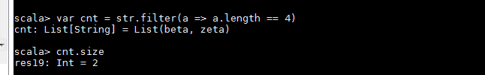

- convert the list of string to a list of integers, where each string is mapped to its

corresponding length

**var asgnmnt = List("alpla","beta”,"gamma","zeta","omega")**

**asgnmnt.map(s=> s.length)**

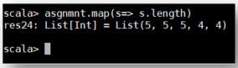

- find count of all strings which contain alphabet ‘m’

**var str = List("alpla","beta”,"gamma","zeta","omega")**

**var mList = str.filter(a =>( a.count(_ == 'm') != 0))**

**mList.size**

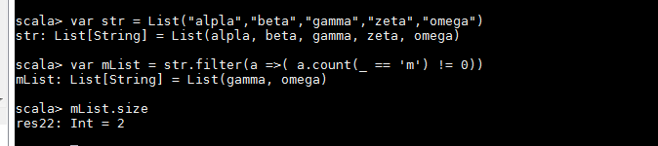

- find the count of all strings which start with the alphabet ‘a’

**var str = List("alpla","beta”,"gamma","zeta","omega")**

**var mList = str.filter(a =>( a.head == ‘a’)).foreach(println)**

